Task 4: Network Intrusion Detection System (NIDS)

Objective
The objective of this project was to monitor network traffic, identify suspicious activities, and understand how a Network Intrusion Detection System (NIDS) works in a real environment.

Tools Used
- Kali Linux
- Wireshark

Methodology

Step 1: Installation and Setup
Wireshark was installed on Kali Linux and configured to capture packets from the active network interface.

Step 2: Traffic Capture
The network interface was selected and packet capturing was started using Wireshark.

Step 3: Traffic Generation
Network traffic was generated by sending ICMP (ping) requests to the Google DNS server (8.8.8.8).

Step 4: Packet Analysis
Captured packets were analyzed using Wireshark filters. The ICMP filter was applied to observe ping requests and responses.

Step 5: Threat Monitoring
The captured traffic was monitored to identify unusual or suspicious network activities. Packet details such as source IP address, destination IP address, protocol type, and packet timestamps were examined.

Step 6: Response Mechanism
Potential malicious IP addresses can be blocked using firewall rules to prevent further communication with the system.

Results
- Successfully captured network traffic.
- Observed ICMP request and reply packets.
- Applied protocol filters to analyze specific traffic.
- Demonstrated how network activities can be monitored for intrusion detection purposes.

Conclusion
This project demonstrated the basic functionality of a Network Intrusion Detection System. Using Wireshark, network traffic was successfully captured and analyzed. The project provided practical experience in monitoring network communications and detecting potentially suspicious activities.

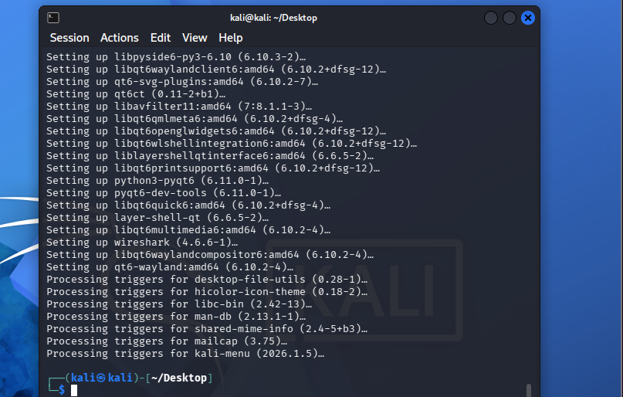

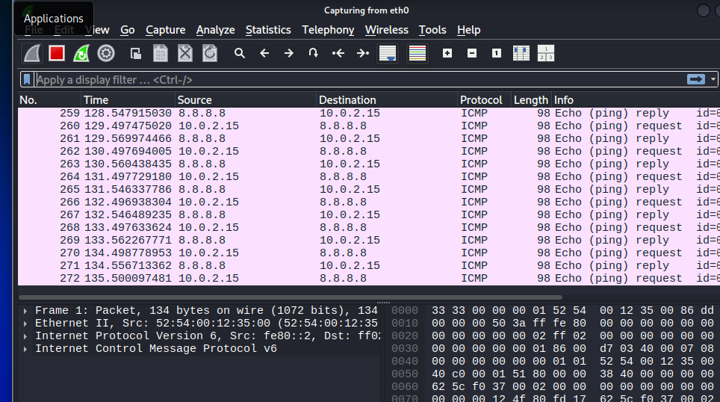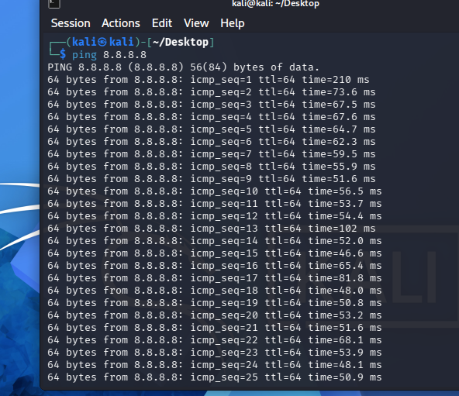ss